Walter Matthews

Adam Brown

**Lab 2 Analysis**

Our code successfully compiled and executed for all memory policies. We designed and implemented in C. We simulate processes in order to test different memory management olicies. We see the same metrics from the previous lab with an addition of ‘Average Wait Time in Job Queue’.

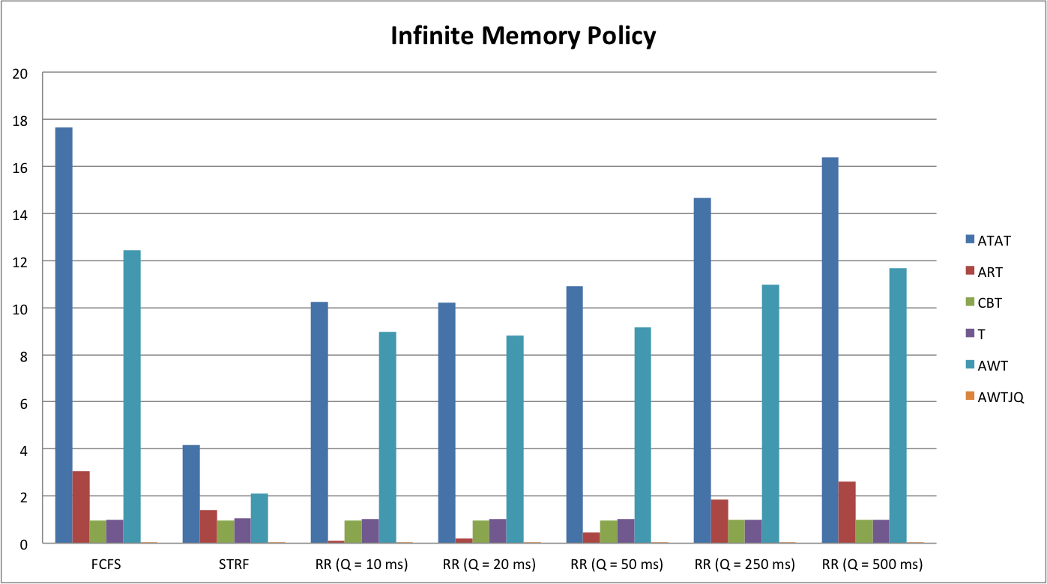

In this program, we act is if we have limitless memory to work with. Although this is impossible in the real world, we can use it for good comparison of metrics. A large discrepancy exists compared to the other memory policies. We see this discrepancy with the metric, Average Wait Time in Job Queue (AWTJQ). With an average of 0.00102, we can see a system with infinite memory would have no need to have jobs waiting in the Job Queue as they can continuously be admitted into the system.

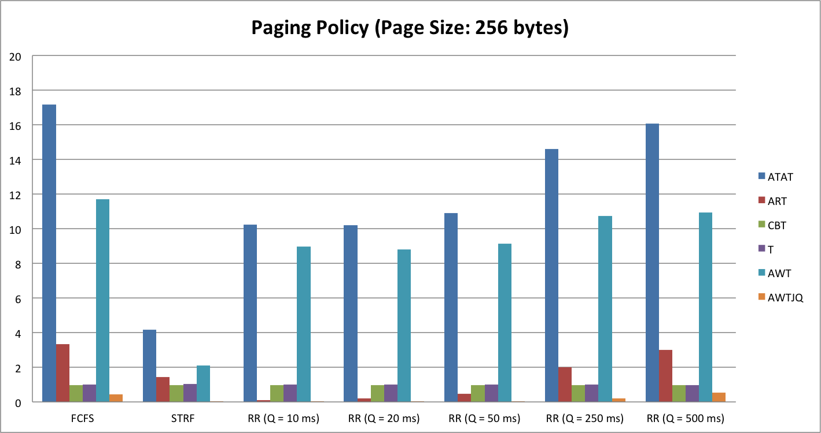

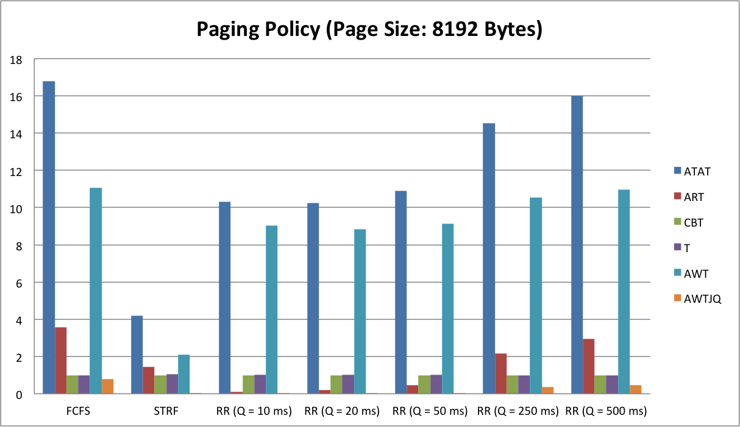

Here we see the results of 2 separate executions implementing the Paging Memory Policy. Paging allows a process to be noncontiguous and split its addresses into “pages”. Here we have 2 different page sizes: 256 bytes and 8192 bytes. Turnaround Time, Response Time, CPU Busy Time, Throughput, and Average Waiting Time were all very similar in both page sizes. We do see a discrepancy in the AWTJQ between the page sizes. The program with the smaller page size has almost .1 less units. Fewer pages can be admitted into the memory at once with a larger page size causing the Job Queue to clog. AWT is lower than all other memory policies with paging policy. Paging allows processes to get in and out of the ready queue in a timely manner.

